CSA1006-SOFTWARE ENGINEERING
M. Mounika (192411083)
CO1 AT-1
CASE STUDY
AI-Based Smart Campus Maintenance Management System
A large university has more than 30 academic buildings, laboratories, hostels, libraries, and sports facilities. Students and faculty frequently report maintenance issues such as broken classroom equipment, damaged furniture, water leakage, electrical faults, and internet connectivity problems. Currently, complaints are submitted manually through paper forms or phone calls, causing delays, duplicate requests, and poor communication between departments.
The university plans to develop an AI-Based Smart Campus Maintenance Management System that allows users to report issues online, automatically prioritizes complaints using AI, assigns tasks to maintenance staff, tracks repair progress, and provides notifications until the issue is resolved.
1. Understanding the Problem Statement
Problem Explanation
The existing maintenance process is slow, manual, and inefficient. Complaint records are difficult to manage, leading to delayed repairs and reduced user satisfaction.
Objectives
- Develop an online complaint management system.
- Automate complaint prioritization.
- Assign maintenance staff automatically.
- Track repair status in real time.
- Generate maintenance reports.
Scope
- Student complaint registration
- Staff complaint registration
- AI-based priority assignment
- Maintenance tracking
- Admin dashboard
- Notification system
- Report generation

2. Stakeholder Analysis

Stakeholder | Responsibilities
Students | Register maintenance complaints
Faculty | Report classroom/lab issues
Maintenance Staff | Repair assigned complaints
Maintenance Manager | Assign and monitor tasks
Administrator | Manage users and reports
University Management | Monitor overall maintenance performance

Challenges
- Delayed complaint handling
- Duplicate complaints
- Poor communication
- Lack of real-time tracking
- Manual report preparation

3. Current System Analysis
Existing Process
- Complaints submitted manually.
- Staff informed through phone or email.
- Repairs tracked manually.
- Reports prepared using spreadsheets.
Strengths
- Easy to understand
- No special software required
Limitations
- Time-consuming
- Data redundancy
- No automation
- Difficult tracking
- Poor transparency
- Problems
- Long repair time
- Complaint duplication
- Lost complaint records
- Inefficient resource allocation

4. Proposed Software Solution
Proposed System
Develop a web-based application with AI-assisted complaint prioritization.
Functional Modules

Module 1: User Management
- Student Login
- Faculty Login
- Admin Login
Module 2: Complaint Registration
- Upload complaint
- Add photo
- Select location
- Submit issue
Module 3: AI Priority Module
- High Priority
- Medium Priority
- Low Priority
Module 4: Maintenance Assignment
- Assign technician
- Update repair status
Module 5: Dashboard
- Complaint statistics
- Pending issues
- Completed repairs
Module 6: Report Generation
- Daily reports
- Monthly reports
- Performance reports
Functional Requirements
- User Registration
- Login
- Complaint Submission
- Complaint Tracking
- Notification System
- Admin Dashboard
- Report Generation
Non-Functional Requirements
- Fast response time
- Secure login
- High reliability
- Easy to use
- Scalable architecture
- Data backup
Software Engineering Principles Used
Modularity
Separate modules for login, complaint, reports, dashboard.
Scalability
Supports increasing users and buildings.
Maintainability
Easy to update modules independently.
Reliability
Automatic backup and validation.
Usability
Simple user interface.
Security
Password encryption and role-based access.
5. SDLC Justification
Selected Model
Agile SDLC
Why Agile?
- Requirements may change.
- Easy to add new features.
- Continuous testing.
- Frequent customer feedback.
- Faster delivery.

Agile Process
Requirement Gathering
↓
Planning
↓
Design
↓
Development
↓
Testing
↓
Deployment
↓
Maintenance

6. Expected Outcomes
Benefits
- Faster complaint resolution
- Better maintenance planning
- Reduced paperwork
- Improved transparency
- Increased user satisfaction
- Better resource utilization
Addressed Challenges
- Eliminates manual records
- Reduces duplicate complaints
- Provides real-time updates
- Improves communication
Risks
- Internet dependency
- User training required
- Initial implementation cost
- AI prediction errors
Future Enhancements
- Mobile application
- Voice complaint registration
- IoT sensor integration
- Predictive maintenance
- QR-code based complaint registration

Output

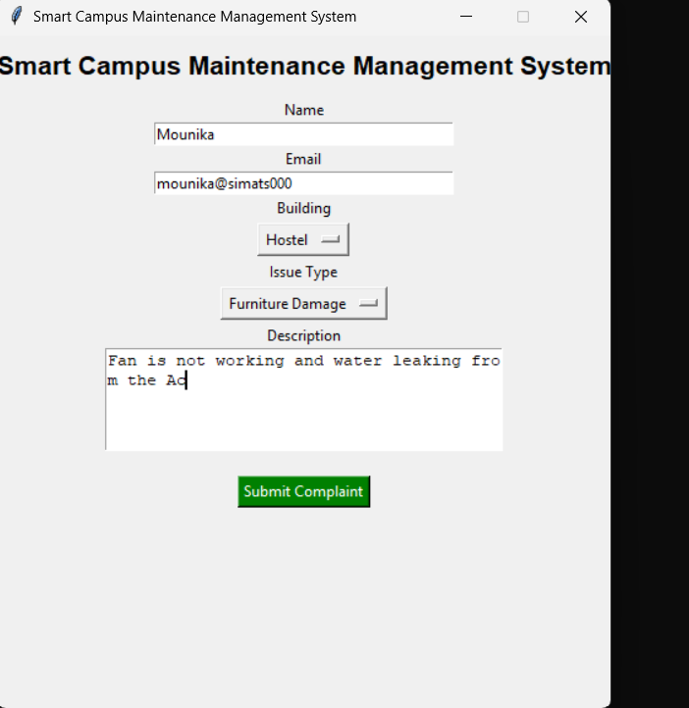
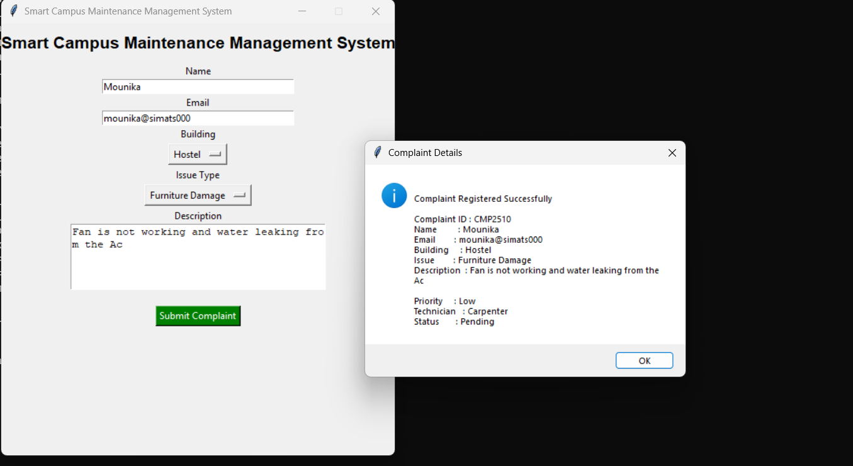

Conclusion
The proposed system improves the efficiency, transparency, and reliability of campus maintenance management. By using Agile SDLC and software engineering principles, it provides a scalable and user-friendly solution that enhances user satisfaction and can be further improved with AI, mobile apps, and IoT integration in the future.

